Job description  Facilities Management Team Leader  (Ref. 002024) | 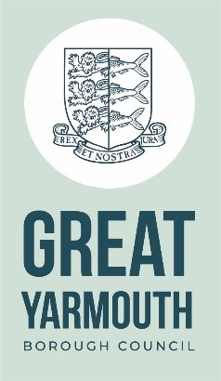

Portfolio based

Reports to: Property and Asset Manager

Responsible for - Directly: 4x Porters, 2x Marketplace Officers, Maintenance Officer

Total staff managed: 7

Working environment: OFFICE/HYBRID/SITE VISITS

Purpose of role:

The post holder will have an interesting and varied role covering all aspects of asset management and property development work and will report to the Property and Asset Manager.
The Primary function of the role will be to lead the Facilities Management team to ensure that all building related functions are carried out across the commercial portfolio.
Key result areas:
Operational responsibilities
- To ensure that all porterage related duties are programmed and managed across the corporate portfolio

- To liaise and support the events team in ensuring relevant cover is provided for events

- To ensure that good practice and policy is adhered to within the team

- To audit and review the outputs of the facilities management team

- To ensure that the market place has suitable cover and relevant tasks are completed as per the delivery plans

- To ensure that the cleanliness of the buildings is kept to a high standard

- To oversee the maintenance and operation of the corporate buildings, equipment and local grounds.

- To programme in any maintenance related tasks associated to the commercial portfolio

- To ensure that tasks are delivered in accordance with H&S and compliance guidelines

- To undertake any other duties consistent with those listed above and appropriate to the title and grade of the post.

The above may change subject to consultation with the post holder.
This job description sets out the duties and responsibilities of the job at the time when it was drawn up. Such duties and responsibilities may vary from time to time without changing the general character of the duties or the level of responsibility entailed. Such variations are a common occurrence and cannot in themselves justify a reconsideration of the grading of the job.

Person specification

Development Surveyor
Experience/  Knowledge | Three years’ experience in a similar role.  Knowledge of local government operations.  Political awareness and experience of operating in a political environment.  Understanding of building and operations.
Qualifications | Relevant FM qualifications recommended.
Competencies | Experience of presenting property advice both verbally and in writing.  Able to operative productively within boundaries based on Council policy, standing orders, legislation etc.  Demonstrates a personal commitment to quality and customer focus.  Strong knowledge of property maintenance and building management.  Excellent analytical, negotiation, and communication skills.  Full driving licence (car).
Personal Qualities and Attributes | Self-awareness, confident, thorough, professional outlook.  Flexible, approachable and able to work on own initiative.  Ability to work under pressure and to deadlines.  Enthusiastic about new initiatives and keen to be involved.
Behaviors |   Effective communication  Working Together  Taking personal responsibility  Putting Great Yarmouth first  Respecting others  People focused  • Embracing change

