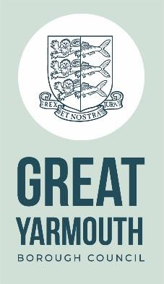

Job description

**Junior Graphic Designer (Ref: 001344)**

**Reports to**

Print and Design Manager

**Responsible for Directly**

0

**Grade**

4

**Total staff managed**

0

**Working environment**

Office based – some site visits to assess design requirements

**Working Hours**

37 hours per week over 7 days depending on business requirements

**Purpose of role**

* To work as part of the Council’s Marketing, Engagement and Events Team and under the supervision of the Council’s Print and Design Manager, to produce and design hard copy and digital artwork for council services including co-production of marketing concepts.

**Key result areas:**

**Corporate Responsibilities**

•

To support the Marketing Engagement & Events Team and other colleagues in the production of

all council marketing collateral and graphic design work, ensuring that concepts are relevant to the target audience and comply to brand requirements.

**Operational responsibilities**

•

•

•

To provide creative design support to the Marketing, Engagement & Events Team.

To work with a range of media and be up to date with industry leading software.

To work on multiple design jobs at any one time and to schedule work commitments to ensure all deadlines are met.

To ensure all stationery and form templates (on and offline) are kept up to date with the correct branding and are accessible and intuitive.

To proactively proof final artwork.

To work as part of a team with communications, marketing and print room colleagues.

•

•

•

**These may change subject to consultation with the postholder.**

**This job description sets out the duties and responsibilities of the job at the time when it was drawn**

**up. Such duties and responsibilities may vary from time to time without changing the general**

Evaluated: 4 September 2020

**character of the duties or the level of responsibility entailed. Such variations are a common occurrence**

**and cannot in themselves justify a reconsideration of the grading of the job.**

Evaluated: 4 September 2020



Person specification

Evaluated: 4 September 2020

**Junior Graphic Designer**

**Experience/ Knowledge**

Experience of creating quality graphic designs within a similar role or through education.

Good understanding of the impact of communications and marketing for services and businesses.

Experience of working with a range of software packages e.g. Microsoft Office as well as Adobe design packages.

**Qualifications**

Level 3 design qualification.



Evaluated: 4 September 2020

**Competencies / Skills**

Competent in design programmes e.g. Adobe Photoshop, Illustrator, Acrobat, InDesign etc.

Able to work under pressure High level of attention to detail.

Well organised, able to plan workload and prioritise.

Ability to present ideas both verbally and visually and to listen to and understand

client’s requirements and their feedback.

Ability to convey design ideas.

**Personal Qualities and Attributes**

Willing to learn all design aspects, including illustration. Adaptive, dependable and keen to get involved.

Excellent communication skills.

Ability to work efficiently, flexibly, remain calm and be positive. Can use their own initiative to solve problems.

Conscientious, reliable with a can-do attitude. Creative and inspiring.

**Behaviours**

Effective communication Working together

Taking personal responsibility Putting Great Yarmouth first Respecting others

People focused Embracing change

**Personal Circumstances**

A flexible approach to working hours is required to reflect business need.